GL 1.3 Interpolation
Subject: Science, math Topic: Reading Graphs
Grade: 6-8 Designer: Sara Remsen
Time: 40 minutes

Stage 1 – Desired Results

Lesson Overview: The goal of this activity is to help students learn how to interpolate between data points in a table or on a graph. The activity challenges students to use the location of a sequence of train stations, along with the elapsed travel time, to estimate when the express train arrives at the intermediate stations. This is an exercise in reading a table and doing simple calculations on the data represented (e.g., subtracting one value from another). The table is incomplete and the student fills in the missing values as s/he progresses, ultimately labeling each town based on the table. All of the calculations are for miles traveled or elapsed time in minutes.

Standards Addressed:
CCSS.Math.Content.6.RP.A.3 | - Use ratio and rate reasoning to solve real-world and mathematical problems, e.g., by reasoning about tables of equivalent ratios, tape diagrams, double number line diagrams, or equations.
NGSS MS-PS3-1 | Analyzing data in 6–8 builds on K–5 and progresses to extending quantitative analysis to investigations, distinguishing between correlation and causation, and basic statistical techniques of data and error analysis. Construct and interpret graphical displays of data to identify linear and nonlinear relationships.
CCSS.Math.Content.7.RP.A.2 | Recognize and represent proportional relationships between quantities.

Students will be able to:  - Read a data table  - Match the existing dataset to a graph  - Interpret between the data to fill out the table and to create a graph  - Create a relationship between variables | Essential Questions:  - How does recognizing a relationship between two data points allow you to make inferences about the points in between them?  - How can you estimate one variable based on its relationship with another variable?  - How does a data set seem different in a table or in a graph, and how can you work between them?
Stage 2 – Lesson Plan
Lesson preparation
- Students should be familiar with plotting points on a graph and with ordered pairs i.e. (0,0)
- Students should be able to read scales on graph axes
- Students should be able to read tables and make graphs from them
- No knowledge of slope is necessary
- Students will need to do some simple conversions of time to elapsed minutes, though most of the calculations are done for the students. For example, they will need to recognize that a train that leaves at 6:15am and passes through a town at 8:15am has traveled for 120 minutes.

Procedure
- Students will use computers/tablets for this activity. Students should not need calculators, but they might find them useful. (The activity takes about 30-40 minutes).
- As an extension, you can print out the cricket activity worksheet at the end of this lesson. It covers some of the same ideas, but asks students to fill in the gaps in the table and create the graph themselves. The cricket activity introduces the concept of a linear function, where a proportional relationship between the variables defines the relationship. (This activity takes about 15 – 20 minutes.)
Further discussion questions

- How did you know when a train arrived at a certain town?
Students should have noticed that it took a certain amount of time to go between stops, and then interpolated from the times they already knew. For example, if they know the train passes through several towns in a specific order, those data points will also appear consecutively on the graph. Students can also identify the towns from one of the variables that are given. For example, if the miles traveled are given, a student could recognize the town under the assumption that each town is a unique number of miles away.
- Was it easier to use a graph or a table to understand the problems?
Students may say that they preferred a table because they could fill it out as they worked or a graph because they could visually see the relationships between variables.
- What did you learn about making inferences about data you didn’t have (based on data you did have)?
Students should say that they could use the information they did have and make guesses (inferences) about the data they don’t have. They might also say that they were able to use one variable to determine another one, or that they recognized the relationship between data points (consecutive, for example) and then used that information to label towns, etc.

Resource Table and Graph

Completed table found in activity:

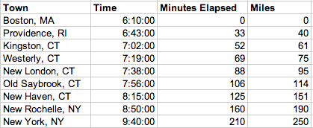

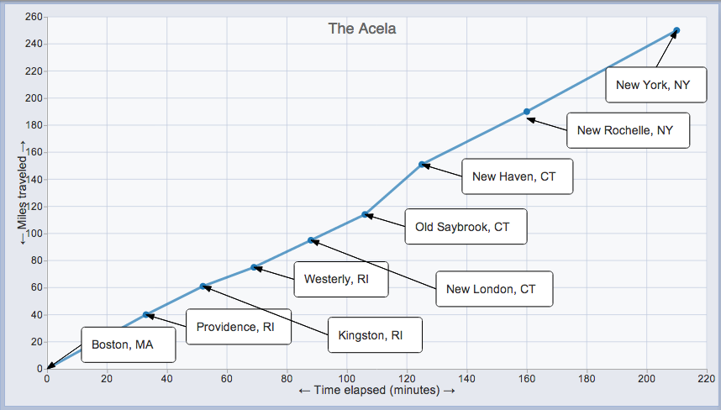

Name:____________ Date:_______
Crickets and Thermometers (post-activity)
Did you know that crickets are thermometers? It’s true! The number of chirps that a cricket makes in a minute depends on the temperature so if you time the cricket you can tell how hot it is! Here’s a table that will help you:
Chirps per minute | Temperature (in Fahrenheit degrees)
40 | 50ºF
60
80 | 60ºF
100 | 65ºF
120
140
Oops! We’ve left out some of the entries in the table. But that’s OK – you can figure those out for yourself. (Hint: the relationship between chirps and temperature is linear.)
1) Fill in the missing entries in the table above.
This table will work as long as the temperature is divisible by 5, but most of the time it won’t be. What do you do then? Well, you could make a graph…
2) Using graph paper, graph the points on the table above.
Now can you tell from the graph what the temperature is if the cricket is chirping 58 times per minute? (Hint: it might help if you connected the points on your graph with a line.)
3) If the cricket is chirping 58 times per minute, what is the temperature? _______

4) If the temperature is 82ºF, how many chirps would you expect per minute? _______

That was easy! But what if you’re out in a field sometime with a bunch of crickets and you’ve left your graph behind? How will you know what the temperature is? How about a formula that will convert from chirps to degrees? It’s easier to remember a formula than to remember to carry a graph around.
5) Explain in words how you could figure out the temperature by counting the number of chirps in a minute.

6) Write a formula that gives the number of chirps per minute as a function of the temperature in degrees Fahrenheit.

